**PRODUCT DESIGN THINKING FRAMEWORK**

**-QUANTUM UNIVERSITY**

**-01**

**-TASK NO.01**

**- Fix and Prepare an Agile board of any product of your choice**

TASK 1

# ***Fix and Prepare an Agile board of any product of your choice***

I pick a **fitness tracking mobile app** as the product for this Agile board

## **SCRUM MODEL**

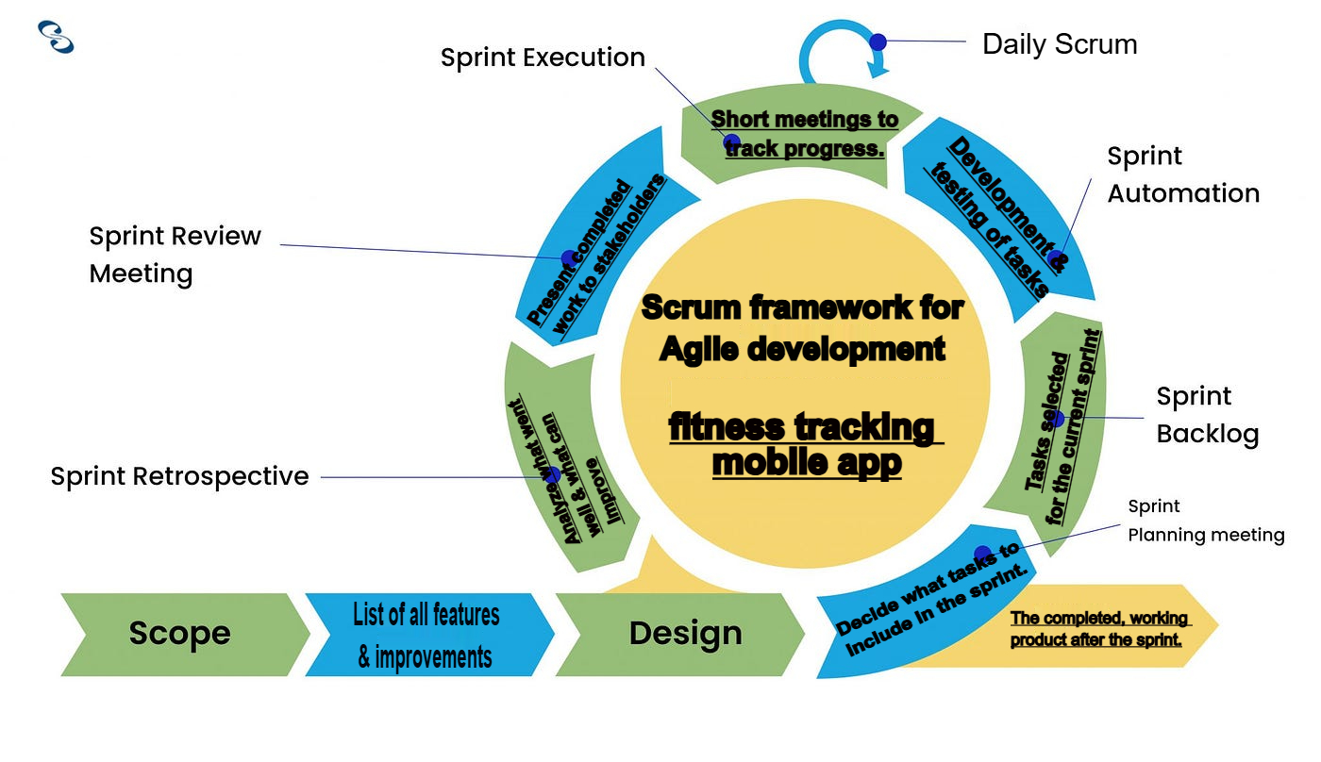

## **AGILE BOARD**

